Cloud Fiori Launchpad Theme Designer:

**Step1:** login to cloud Fiori launchpad

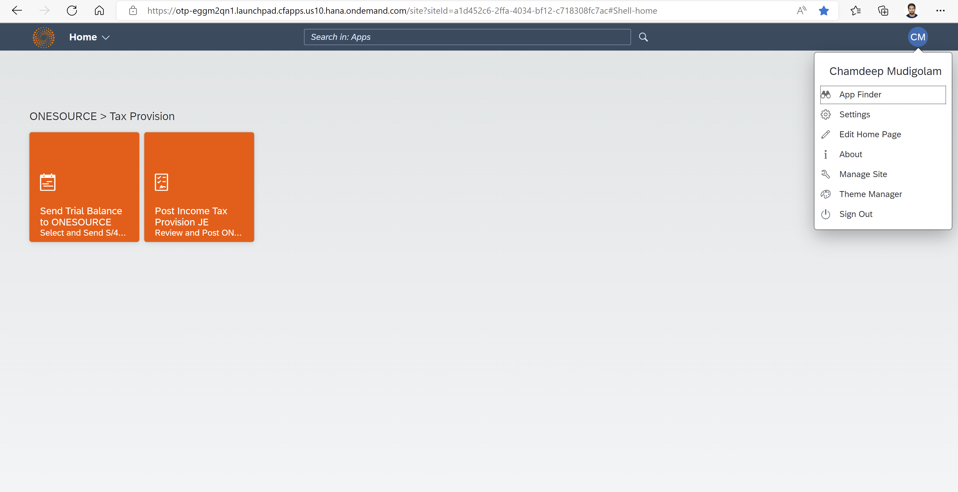

**Step2:** On profile choose **theme manager**

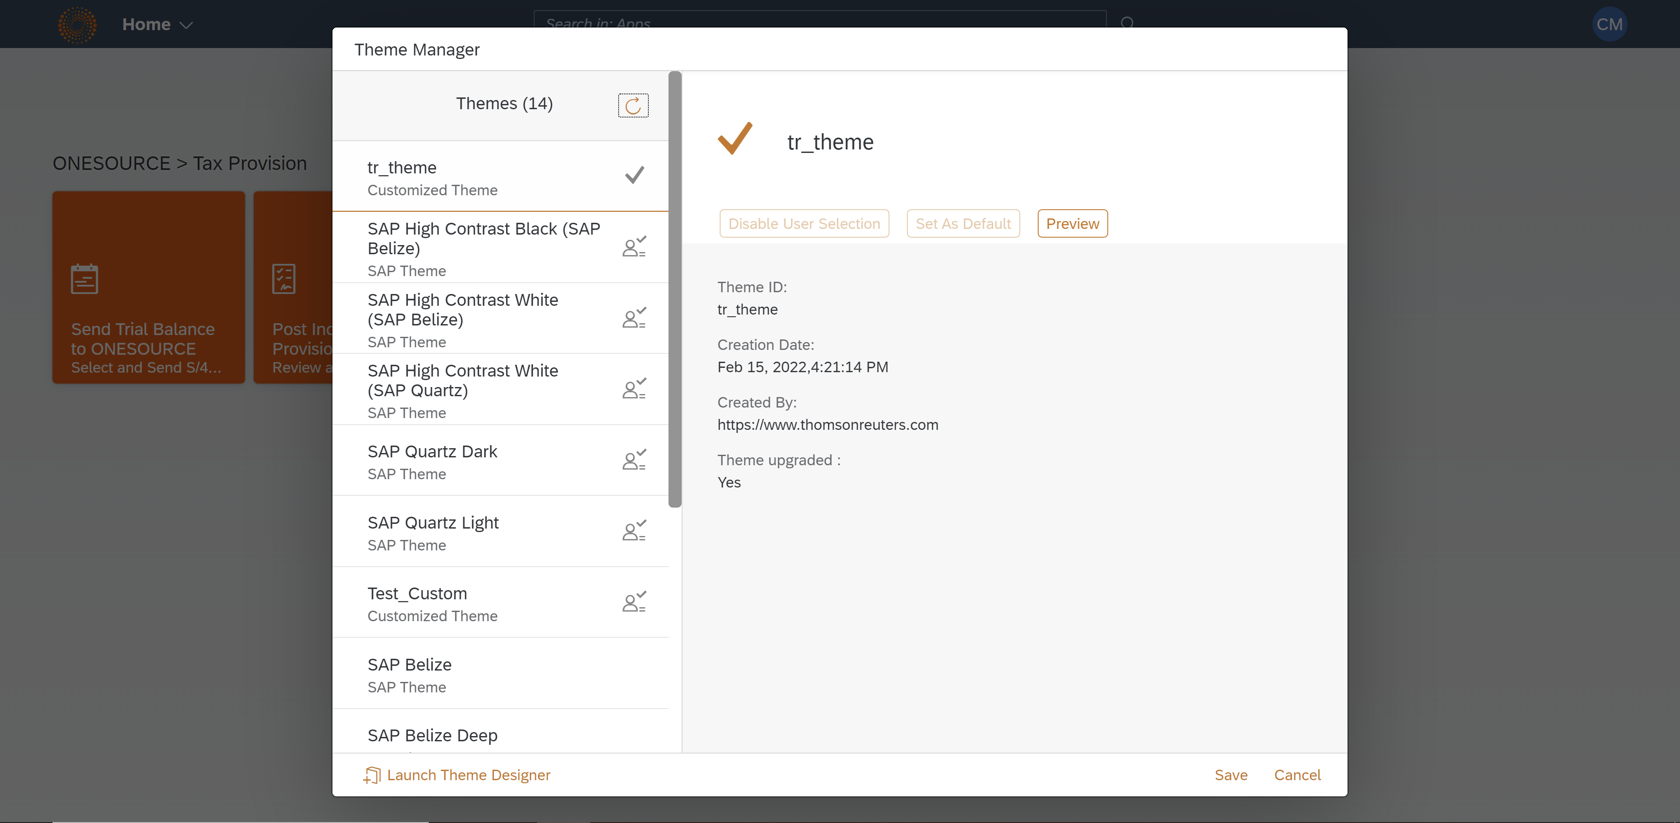

**Step3:** Select **Launch Theme Designer** at footer right side. It will open in new tab.

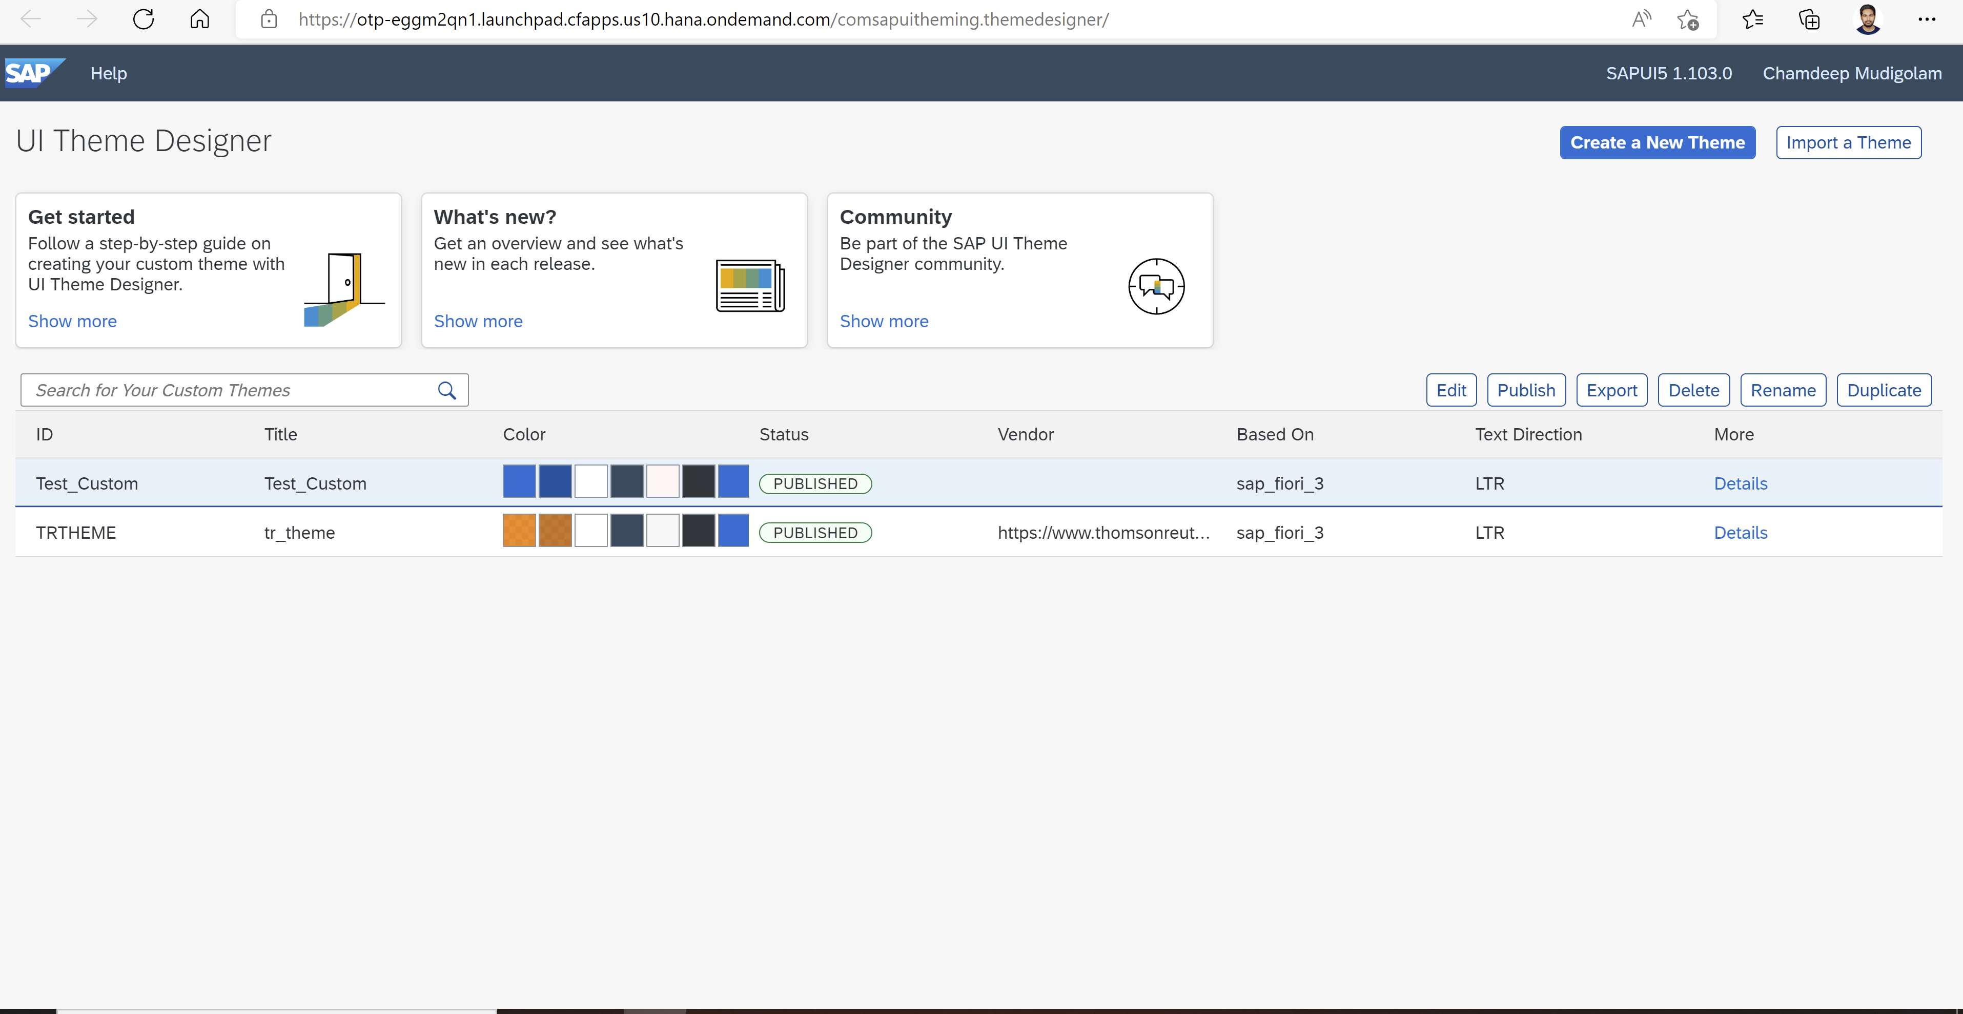

**Step4:** If you want to create new theme click on **Create a New Theme**.

